Group Project

Center IN128 (The Galaxy School)

Candidate Name | Candidate Number
Ajay Jagani | 0011
Aliasgar Bharmal | 0017
Dhruvin Doshi | 0037
Niyati Fatehpuria | 0015
Vishnupriya Jadeja | 0034

Aims and Project Plan
The aim of this project was to create and spread awareness about the utilization of public transport. We felt that public transport is being underutilized, and so thought about trying to promote its use.

The project plan is to research and know about public transport and its utilization around the world. Using public transport has many benefits we want to highlight such as – time saving, energy saving & reducing pollution. Other than the environmental effects, it is convenient to use too. We want to investigate how it affects people in different parts of the world. we plan to do this by talking to out friends and family who live in different countries and surveying people in our local community.

Rationale
Just by talking to our peers we discovered that none of them used public transport, not even once a year! We wanted to know that is it only our class or does the entire world think similarly. After talking to our classmates, we discovered that traffic is a major problem in Rajkot, and during festivals and celebrations, it becomes a headache to get out of the house in a car. Our parents say that parking space is not available in the busy places they normally visit.

Also lately, the BRTS bus service has been introduced in our city. The route it takes is right beside our school. We see it very often and could connect it to other public transport solutions we have come across, like the Mumbai local trains and the Delhi metro. Experiences of all these have been quite unique. That built up more curiosity for the topic.

Intended outcome
In the beginning of the project we were not really sure what to do. We made up our minds on making a presentation, either using PowerPoint or Prezi. After talking about it and seeing different examples we came to know that PowerPoint looked formal, therefore a better method of presentation. We got our survey done in a tabular format, which is easy to interpret and also include in our presentation. Till the very last day we had it in our minds that our final outcome was going to be a PowerPoint Presentation, but then we decided on making a document, which will not be a presentation of facts, instead, comparison of effects of usage of public transport on different countries.

Delegation of group tasks

Ajay Jagani | Cross culture collaboration and reviewing of gathered data
Aliasgar Bharmal | Artwork and keeping a record of activities done.
Dhruvin Doshi | Research and compilation of data
Niyati Fatehpuria | Research and cross culture collaboration
Vishnupriya jadeja | Research and artwork

Group Meeting Log: -

Meeting 1
Date | 2nd January 2013, Wednesday
Agenda | - Chose the topic on which we want to work for our group project  - Divide research work
Tasks completed. | - Chose the topic on which we want to work for our group project- Transport and Infrastructure.
Task division | - Recorder: - Aliasgar Bharmal
Work to be done before next meeting. | - Do background research for deciding on the outcome of the project.  - Bring suggestions the focus question
Pending tasks | - -

Meeting 2
Date | 9th January 2013, Wednesday
Agenda | - Discuss and finalize on a topic  - Formulate focus question  - Discuss how research can be conducted  - Divide roles based on our strengths and weakness
Tasks completed. | - Divided roles according to our strengths and weakness for researching our group project  - Topic decided
Task division | - Recorder: - Aliasgar Bharmal  - Divide roles – Ajay Jagani  - Make a research plan – Dhruvin Doshi
Work to be done before next meeting. | - Decide on the outcome for our group project  - Bring suggestions for the focus question
Pending tasks | - Research left to be divided.  - Formulate the focus question

Meeting 3
Date | 16nd January 2013, Wednesday
Agenda | - Discuss and decide the outcome for our group project  - Formulate focus question  - Divide research work
Tasks completed. | - Discussed the possible outcomes, shortlisted 4; PPT, video, case study & interactive website.  - Focus question formulated  - Research work divided.
Task division | - Recorder: - Aliasgar Bharmal  - Formulate research question – Vishnupriya Jadeja
Work to be done before next meeting. | - Local research – problems related to public transport  - Personal research – survey about how public transport is being utilized.  - Start cross culture collaboration.
Pending tasks | - -

Meeting 4
Date | 21st January 2013, Monday
Agenda | - Compile survey data  - Organize data  - Discuss previous research done, and share it with other group members.
Tasks completed. | - Survey data compiled  - Collected data put into a tabular format
Task division | - Recorder: - Aliasgar Bharmal  - Compile data – Dhruvin Doshi and Niyati Fatehpuria  - Circulate data – Ajay Jagani
Work to be done before next meeting. | - Circulate research work for others  - Bring possible designs and layout for the power point presentation
Pending tasks | - Circulate prior research.

Meeting 5
Date | 30nd January 2013, Wednesday
Agenda | - Start researching on the topic  - Cross culture collaboration work to be distributed/assigned
Tasks completed. | - Cross culture collaboration assigned to Ajay and Niyati  - Research about status and usage of public transport in different parts of the world and places in India
Task division | - Recorder: - Aliasgar Bharmal
Work to be done before next meeting. | - Submit our research to Dhruvin & Ajay in form of PowerPoint presentation for compilation.  - Continue research on assigned topics.
Pending tasks | - Research not complete.

Meeting 6
Date | 4th February 2013, Monday
Agenda | - Compile research and filter for important pointers.  - Start individual assessments
Tasks completed. | - Research of local and personal relations to the issue/topic finished.
Task division | - Recorder: - Aliasgar Bharmal  - Filtration of data – Ajay Jagani
Work to be done before next meeting. | - Research about national and global status of public transport.
Pending tasks | - Data left to be reviewed

Meeting 7
Date | 13nd February 2013, Wednesday
Agenda | - Review PowerPoint presentation made by Dhruvin and edit if necessary  - Discuss public transport issues, focusing on Rajkot  - Inquired and gathered data from RMC source
Tasks completed. | - PowerPoint assessed and passed on to Vishnupriya for formatting and designing
Task division | - Recorder: - Aliasgar Bharmal  - Edit PowerPoint Presentation – Dhruvin Doshi
Work to be done before next meeting. | - Take pictures of public transport in Rajkot.  - Cross culture collaboration to be continued
Pending tasks | - RMC response pending.

Meeting 8
Date | 21st February 2013, Thursday
Agenda | - Complete cross culture collaboration  - Make poster for awareness
Tasks completed. | - Cross culture collaboration complete and compiled.
Task division | - Recorder: - Aliasgar Bharmal  - Cross culture collaboration – Ajay Jagani  - Poster – Vishnupriya Jadeja and Aliasgar Bharmal
Work to be done before next meeting. | - Poster not ready.

Meeting 9
Date | 25th February 2013, Monday
Agenda | - Discuss outcomes of cross culture collaboration, and come up with ideas for its presentation.
Tasks completed. | - See PowerPoint presentation design and improve design.  - Final reviewing of collected data.
Task division | - Recorder: - Aliasgar Bharmal
Work to be done before next meeting. | - Prepare documents or required material for surveying students in the school.
Pending tasks | - -

Meeting 10
Date | 1st March 2013, Friday
Agenda | - Complete survey  - Complete poster  - Start making the document for submission.
Tasks completed. | - Survey complete  - Submission document half way through.
Task division | - Recorder: - Aliasgar Bharmal  - Complete poster – Aliasgar Bharmal and Vishnupriya Jadeja  - Make Document – Niyati Fatehpuria
Work to be done before next meeting. | - Get feedback of research from seniors and teachers.  - Complete poster.
Pending tasks | - Poster not yet complete.

Meeting 11
Date | 5^{dh} March 2013, Tuesday
Agenda | - All tasks and documents to be reviewed  - All documents to be compiled and circulated  - Complete poster
Tasks completed. | - All documents reviewed and circulated.  - Poster ready.
Task division | - Recorder: - Aliasgar Bharmal  - Get feedback – Ajay Jagani and Dhruvin Doshi
Work to be done before next meeting. | - Take feedback of seniors and teachers.  - Make note of necessary changes that need to be made.
Pending tasks | - -

Meeting 12
Date | 14th March 2013, Thursday
Agenda | - Outcome was mutually agreed upon to be a word document instead of a PowerPoint Presentation.  - Convert all collected data into paragraphs and essay type format.  - Compile everything  - Create document, design format and review content  - Finish making the new (second) poster  - Edit individual assessments
Tasks completed. | - All data converted to paragraphs and submitted to Ajay for compilation.  - Content reviewed and finalized.  - Document passed to Vishnupriya for designing,  - Individual assessments ready for submission
Task division | - Recorder: - Ajay Jagani  - Compiling – Ajay Jagani  - Design – Vishnupriya jadeja  - Artwork – Aliasgar Bharmal
Work to be done before next meeting. | - -
Pending tasks | - -

Appendix I – Local Survey
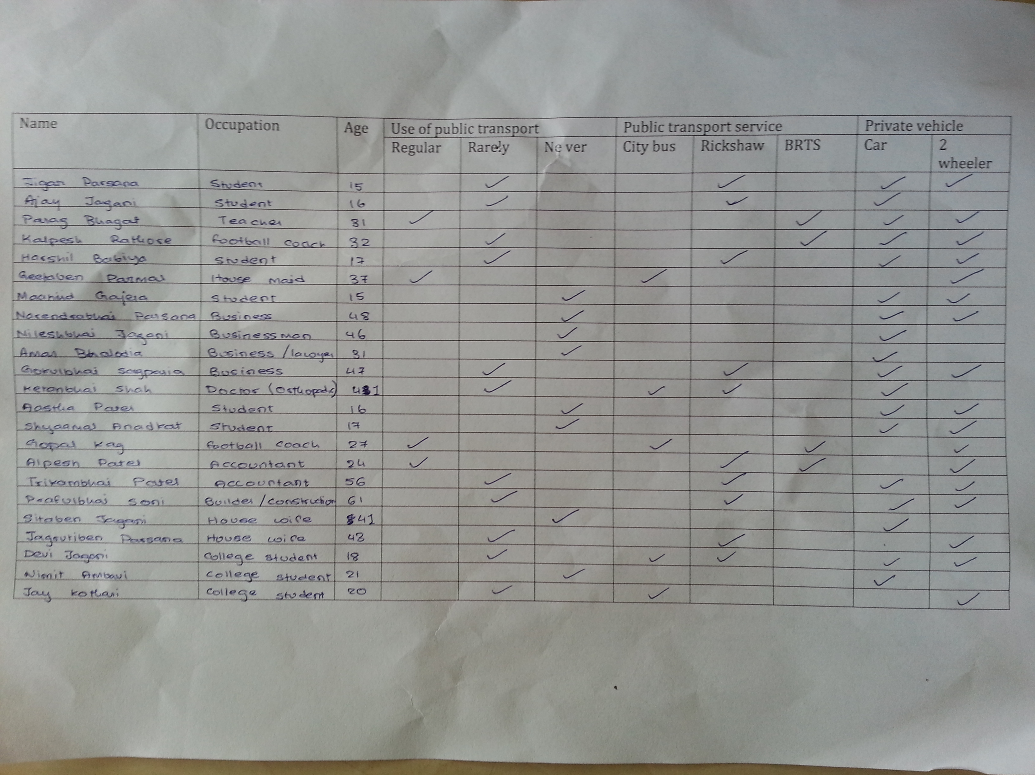

Appendix II – Cross culture collaboration

On Sun, Mar 10, 2013 at 11:06 PM, Ajay Jagani <anjagani@gmail.com>‬ wrote:‬‬‬‬
I need your help for a survey we are doing as a part of our group project in Global Perspective. Can you please answer these questions for us (in context of Rajkot)?

1) What problems does Rajkot face because of underutilization of public transport?
More number of vehicles per family, resulting in more pollution and crowded traffic
2) How can public transport be used better?
Introduce more convenient system, which is on schedule and covers major parts of the town
3) How can public transport be improved?
It can be made cleaner, with well-mannered supervision.
4) How different is the public transport of Rajkot of that of the place you live in?
In Hong Kong the public transport is very cheap, extremely fast when considered taking metro.
5) Do you use public transport? Why? Why not?
Almost everyday I travel by metro, which is very fast (avoids traffic), very cheap (students get 50% off)
6) What are benefits of using public transport compared to private transport?
Shot term effect can save both time and money, long-term effect is reclining rates of pollution.

--
Dhaval Godhani
From: Ajay Jagani <anjagani@gmail.com>;
To: <harshit_hapalia@yahoo.com>;
Subject: Fwd: GP survey
Sent: Sun, Mar 10, 2013 3:07:18 PM

i need your help for a survey we are doing as a part of our group project in Global Perspective. can you please answer these questions for us (in context of Rajkot)?

1) What problems does Rajkot face because of underutilization of public transport?
2) How can public transport be used better?
3) How can public transport be improved?
4) How different is the public transport of Rajkot of that of the place you live in?
5) Do you use public transport? Why? Why not?
6) What are benefits of using public transport compared to private transport?

1) Lots of traffic congestion on the roads. Over consumption of fuel, which is unnecessary, which also leads to pollution.
2) Spreading awareness by campaigns. By providing incentives so that public prefer public transport such as discounts on monthly and yearly passes. Increasing routes to most of the city rather than few routes.
3) For the transport to be improved it has to be started first. I am unaware if it has started. We need some security staff to take care of the busses and punish the hooligans who are damaging the busses. Then over the course of few months we might start getting suggestions, which we could use to improve our quality.
4) I cannot really comment, as I am unaware about Rajkot’s public transport. I need to use it first,
5) Yes. I use it. Public transport is convenient in UK as it covers most of the routes. Plus it’s easy than driving; Fuel efficiency and cheap as well. Pollution is also another driving factor
6) I think there are many benefits and most of them are mentioned in my above answers.
Sent from Yahoo! Mail on Android

Our response is in RED.

Masi [Toral Jagani], Radhika Jagani, & Kaka [Kamlesh Jagani]

From: Ajay Jagani <anjagani@gmail.com>
To: Amar Bhalodia <amarbhalodia@gmail.com>; Kamlesh Jagani <kamlesh.jagani.96@facebook.com>; kamlesh.jagani@yahoo.com; Toral Jagani <rtkjagani@yahoo.com>; "dhaval.godhani@gmail.com" <dhaval.godhani@gmail.com>; harshit_hapalia@handsome.com
Sent: Sunday, March 10, 2013 11:06 AM
Subject: GP survey

i need your help for a survey we are doing as a part of our group project in Global Perspective. Can you please answer these questions for us (in context of Rajkot)?

1) What problems does Rajkot face because of underutilization of public transport?
Rajkot has had no organized public transportation for a long time and therefore the new system will take a while before its peak.
2) How can public transport be used better?
Reducing the use of private vehicles and use public transport when necessary.
3) How can public transport be improved?
Consistency of services. Frequent stops on popular routes and affordability.
4) How different is the public transport of Rajkot of that of the place you live in?
Until recently, Rajkot has had a corrupt political transport system.
5) Do you use public transport? Why? Why not?
Yes we do use public transportation when available because of its convenience.
6) What are benefits of using public transport compared to private transport?
Using public transport helps the environment.

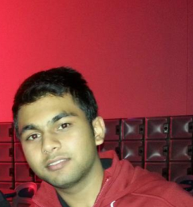
Kishen Shah
South Africa
Age: 19

How do you think has the use of public transport in your country developed since the past few years?
Since we all know majority of African governments are not very capable to spend enough of money for their people, there is not any public transport in my country, which is funded by the government. However, private companies have taken over this industry. There are many mini vans running on all the streets. These vans have done pretty well for the past 5 years. People like it as well and there have been no any complaints for the past years. Initially, there were only a few of these vans in some major cities but now I think that the network is expanding. But I still feel strongly that the government has not played a major role, taking an example of me, I would want public transport available to take me to my university; currently there are no chances for it for the next few years.
Is the use of public transport in m country efficient?
I believe just like other western governments who have done so much by investing millions of dollars in this sector, some capable African governments should do the same. For example, public trains and buses are great examples to start with as far as development of transport is concerned. I am under the impression that if these means of transport start rolling their wheels on the roads and rails of my country, it could be a great relief to my citizens. I understand the government is working at its best to discover some new efficient ways to tackle this problem but yet, tones of work has to be done if we are expecting something very great.

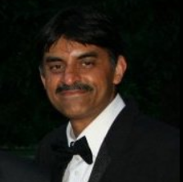
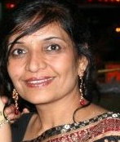
Name: Mrs. Binita Kataria & Mr. Dhiren Kataria
West, Horsham, West Sussex, United Kingdom

What do you have to say about public transport in your country?
The public transport in my country is not only efficient I feel but also very convenient. They range from underground/over ground trains, buses, taxis and in the recent few years even cycles for public use. Both of us have to travel a long distance everyday to go at our work place but it is seldom that we use our car. We think that the public transport runs very effectively and on time and that is how we make sure that we reach at our place of work on time.
How has the public transport benefited your country?
Especially during the London Olympics there was I can say a next-door public transport service available. Buses ran from stadium to stadium carrying in huge amounts of visitors. There are different lanes used for buses, which makes the use all the more safe and faster. You get one ticket for a day to travel wherever you want to do, this has helped me and Dhiren travel for outings on Saturdays. This concept is something known as the oyster card, where you pay some money initially and then top it up again. But we both feel that during after and before Olympics public transport is something that sets a good benchmark for our country as well as our economy as a whole.

Individual Evaluation

Dhruvin Doshi
Candidate no. 0037

Evaluation of project plan and process
when we started the project, we found the topic water food and Agriculture very interesting, we wanted to concentrate on ‘Food shortage and wastage’ which is a major problem in India, but we were a little doubtful about whether will we be able to do it or not. After a lot of pleasant and warm discussion and brainstorming we realized ‘Usage of Public Transportation’ as major global issue as People in India rarely use it. We again had detailed research, long discussions survey and finally decided that our project will concentrate on underutilization of Public transport and how effectively it can be used. Till the end we faced a lot of difficulty in dealing with the current situation and data of public transport. Researching on the topic was the most time consuming part of the process, but I believe it was the most vital part of the project, but it gave us a strong base for our project plan.
After deciding the topic we decided that we will make a Project report as our intended outcome, as we could write it to the point and make it more effective. Vishnupriya took the responsibility of designing the report while Ajay Reviewed our research for the Project report and gathered the data from each one of us. In the beginning we got very excited and out of all the groups we were the first ones to start with the project meetings. I as leader coordinated meetings and made sure that the resources were available. During the process, every week I sorted out the responsibilities and internal conflicts for each of us and all through the week we completed the assigned tasks. This was the strategy which helped me the most in co-coordinating things, there were instances when one of us did not do the assigned task, but then cooperatively we completed it, we also helped each other in finishing tasks forewarning that person not to repeat it again. In the beginning we weren't very well organized but as the deadlines approached we automatically became organized and were able to complete our project according to the final deadline.

We received disappointment when we did not receive any replies from the Rajkot municipal Corporation. Then we went to nearby city Ahmedabad for taking an interview with BRTS officer.
Apart from increasing my Awareness on Public transport, at the end of this project, I also developed a skill of Co-operative learning and leadership, where in I had to co-operate with other 4 peers in achieving the same goal. Though unity was well maintained till the end, we occasionally argued upon some decision making due to opinion clash, as a leader I had to sort this out calmly. The project also helped me in strengthening my relations with Ajay, Vishnupriya, Aliasgar and Niyati at the end of the project we came out to be better friends.

I now have understood the judicious need of public transport in the city. I have started to use rickshaw and BRTS bus on weekly basis. I have also made approximately 15 people near my dad’s office use public transport.
Evaluation of project outcome
I believe that the project repot as a project outcome was very appropriate. Because we thought that our topic requires to be detailed and more specific, thus we made a project report which interests reader’s attention. I believe that our Idea of making a Project report also gave us flexibility of writing to the point and free use of statistics. Our aim was to cover all the relevant points at the global, national and local level, we have been successful. For all of the main content we divided the work, starting from the research work till the final editing, Ali and Niyati took up the global perspective, Vishnupriya took up the National view and I took the local view. We could have improved our teamwork a little bit so that we could have worked more efficiently and reduced the time spent on editing but in all I would say that our idea was innovative and considering that all the group members were doing something like this for the first time, I think the outcome came out well. The project report contains effort of all our group members in some or the other ways. I think the Report is very relevant as the project outcome as it covers everything that is required as far as the project is concerned and it can be accessed by everyone. I feel that our Project is easy to understand and people can simply understand and get influence to use public transport. The awareness spread by the poster was very effective to the citizens of my city. We stuck the posters at the main road network.

Evaluation of Individual Contribution (along with cross culture)
After we were divided into groups, moreover after our first discussion I was little doubtful whether will we all be able to complete our project or not as in the beginning every now and then we were getting stuck and spent a lot of time just thinking. I was assigned the position of the leader, and one of my tasks was to assign work to other group members according to their strengths. Vishnupriya was given the role of designer in the group she had to design the documents. She even helped in the research. Ajay gathered the data and chose the content to put in the Report. He even helped in cross culture collaboration. Niyati helped in cross culture collaboration as well as in research. Aliasgar and Niyati made the poster for spreading awareness. I mainly researched about the local perspective and Global Perspective. I even compiled the data. Awareness in the city was spread out by Ajay and me. We talked to people across our city.

Having a look across Cross culture collaboration we made. I could understand the situation of Public transport from many different points of view and what the Problems currently faced by people in different parts of the world. Cross culture collaboration helped us understand the difference of public transport between India and other countries. From cross culture collaboration we could draw comparisons. These comparisons helped ajay and me to spread awareness about Public transport’s efficiency.

Throughout the process I made sure that at different stages the work was done properly; and I guided the group through difficulties. In the beginning I thought that things are going to be very easy, but as the deadlines approached I had to make sure that work assigned was completed on time, earlier I even thought that I will have to do most of the work, however I realized my job was to just guide my group, encourage them, ensure that work was done and do my part. There were times when we all felt lazy and things did not work the way we wanted, but then that was the time when Ajay [Facilitator] and I had to come in action, at times we had to become strict and make people work. Overall we did not face any disciplinary issues, though sometimes we ended up fighting but throughout we cooperated well. I believe that without the support of the other four members this project wouldn’t have come out so well.
My organization skills, my good communication skills and understanding of what each of the group member would do best and then assigning duties to them were my strengths and that made me a good leader. I love sharing ideas and giving my opinions to the group; therefore I was an active participant in our group discussions and tried to bring out new ideas from my group members by encouraging them to talk more often. Two months before the project submission we met weekly and discussed whatever we researched, analyzed and decided how to proceed with it.
Not just highlighting my positive points, with the progress of the project I realized some of my weaknesses too. Firstly, when things did not happen according to what we planned, I got frustrated and tensed when we were near to our Deadline, sometimes I felt like giving up because we couldn’t work under pressure.
At the end I would say that doing this group project was extremely a unique experience. I learnt a lot many things, I became a good organizer, I learnt to be courteous, I learnt to deal with frustration, became more patient, I learnt to manage my time, most importantly the project helped me to strengthen my leadership skills. I also learnt to multitask and organize my tasks that I had to do.

-------------------------------------------------------------------------------------------------------------------------------------

Word Count- 1440

